**Next:**

How I learned Unity without following tutorials

[**https://www.youtube.com/watch?v=vFjXKOXdgGo&ab_channel=GameMaker%27sToolkit**](https://www.youtube.com/watch?v=vFjXKOXdgGo&ab_channel=GameMaker%27sToolkit)

**continue 8:30**

**gameObject**

**resourceObjects**

**two patches**

**100 <- only elite drone. don't want to sent every drone to this asteroid**

**89 <- only elite drone.**

**70 <- only normal drone**

**50 <- only normal drone**

**30 <- only normal drone**

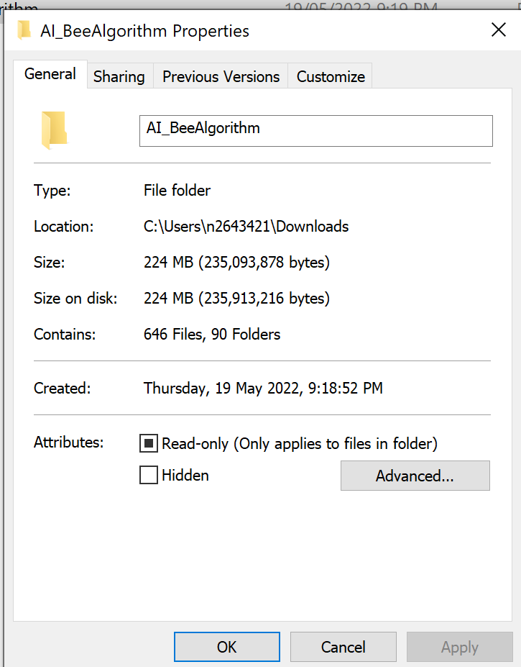

**Github download size 224mb**

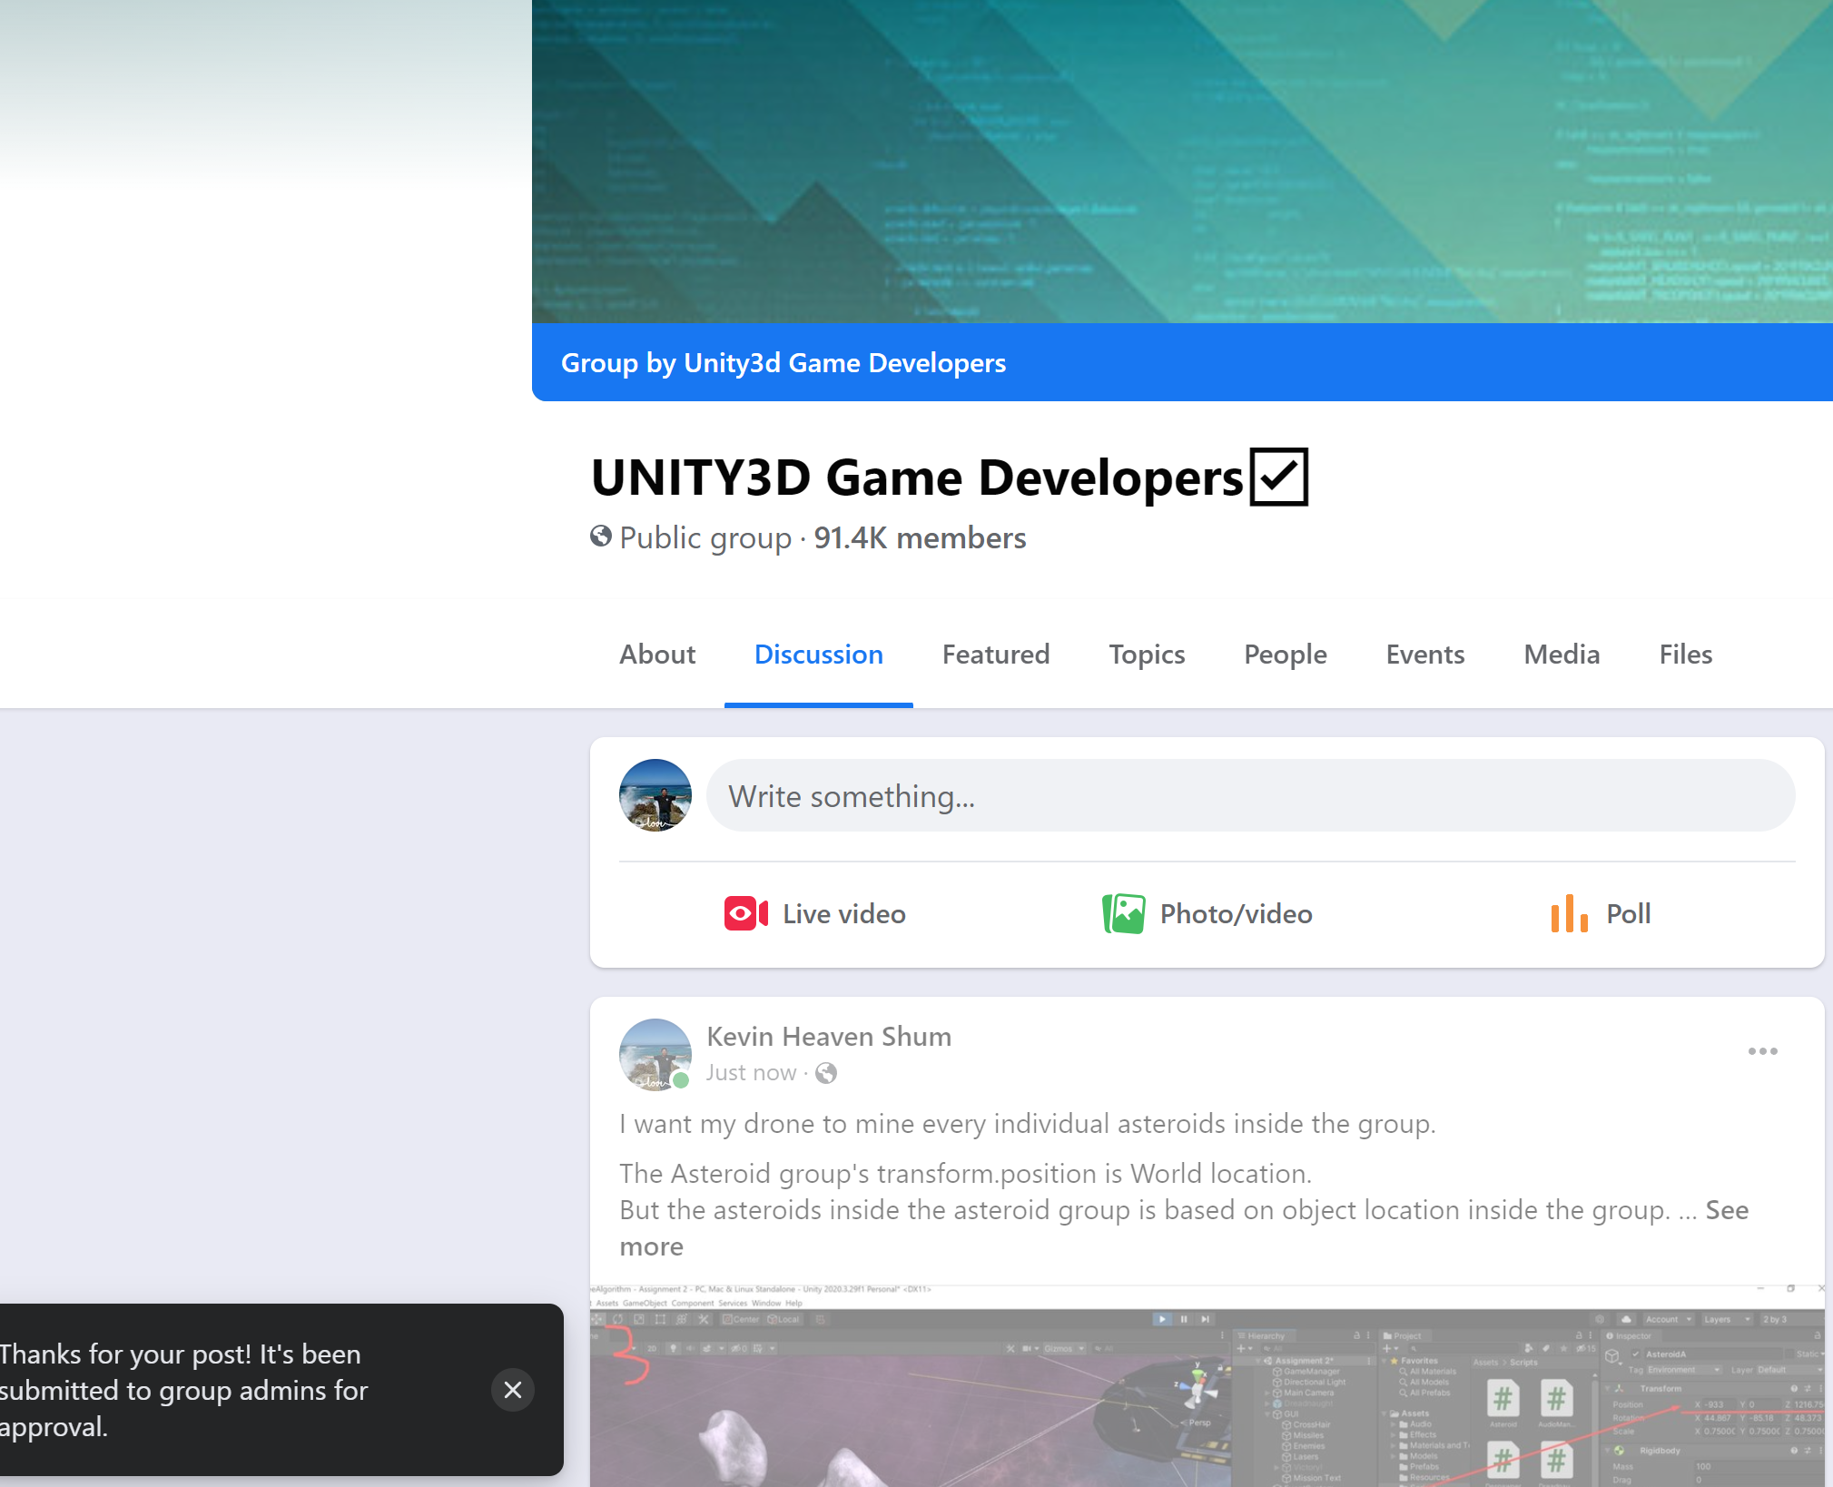

Whole group

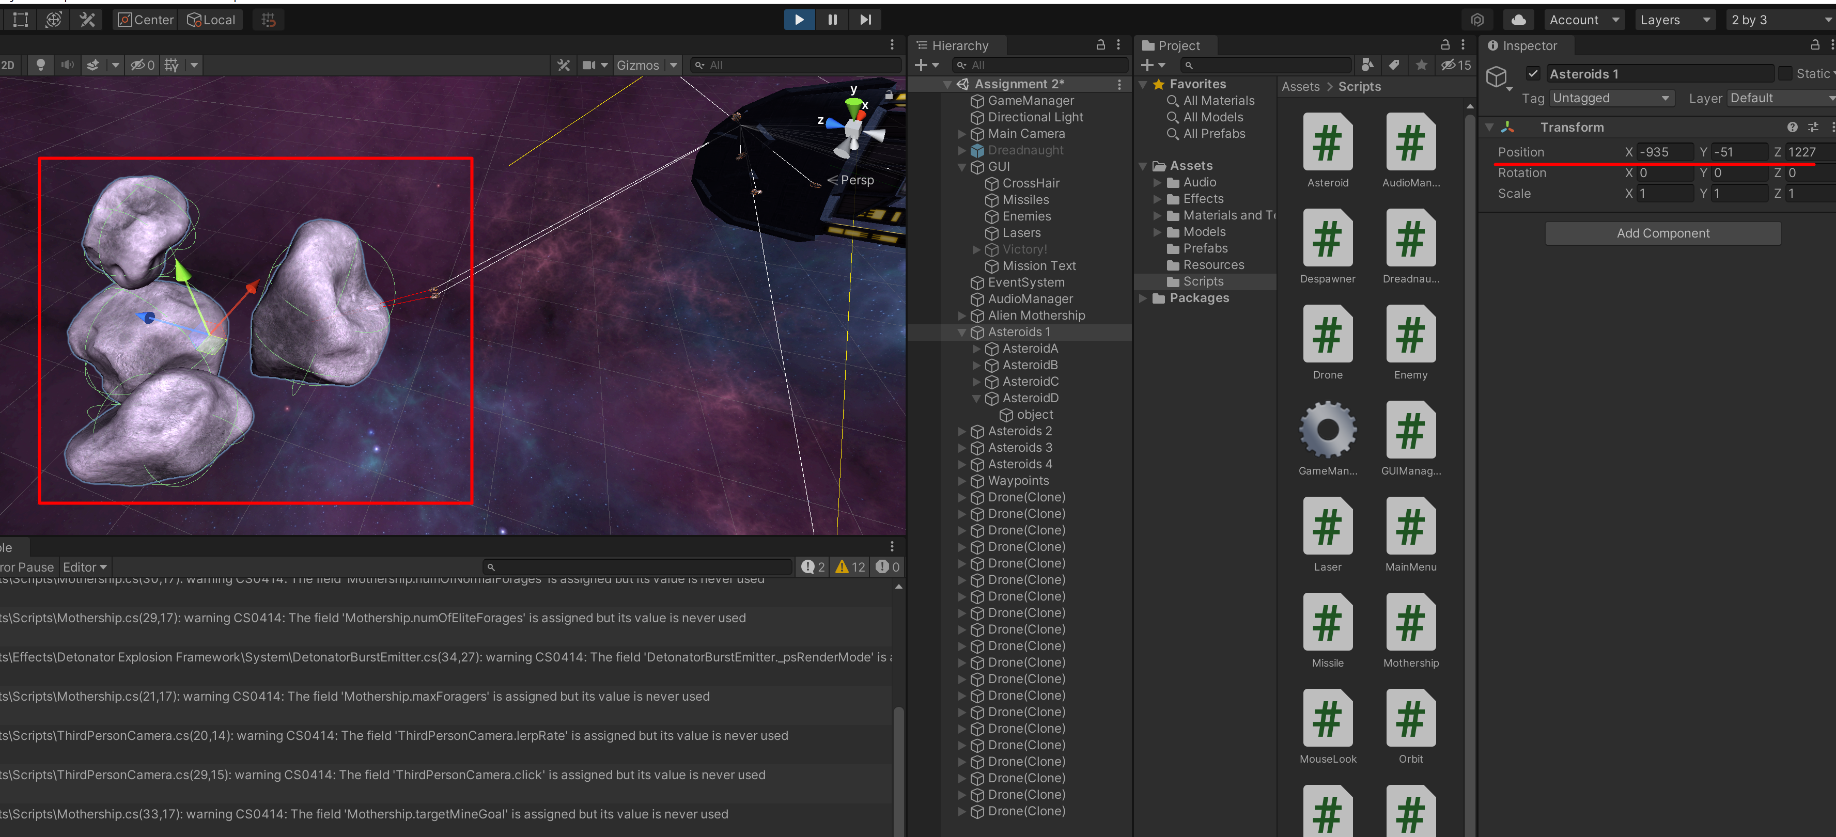

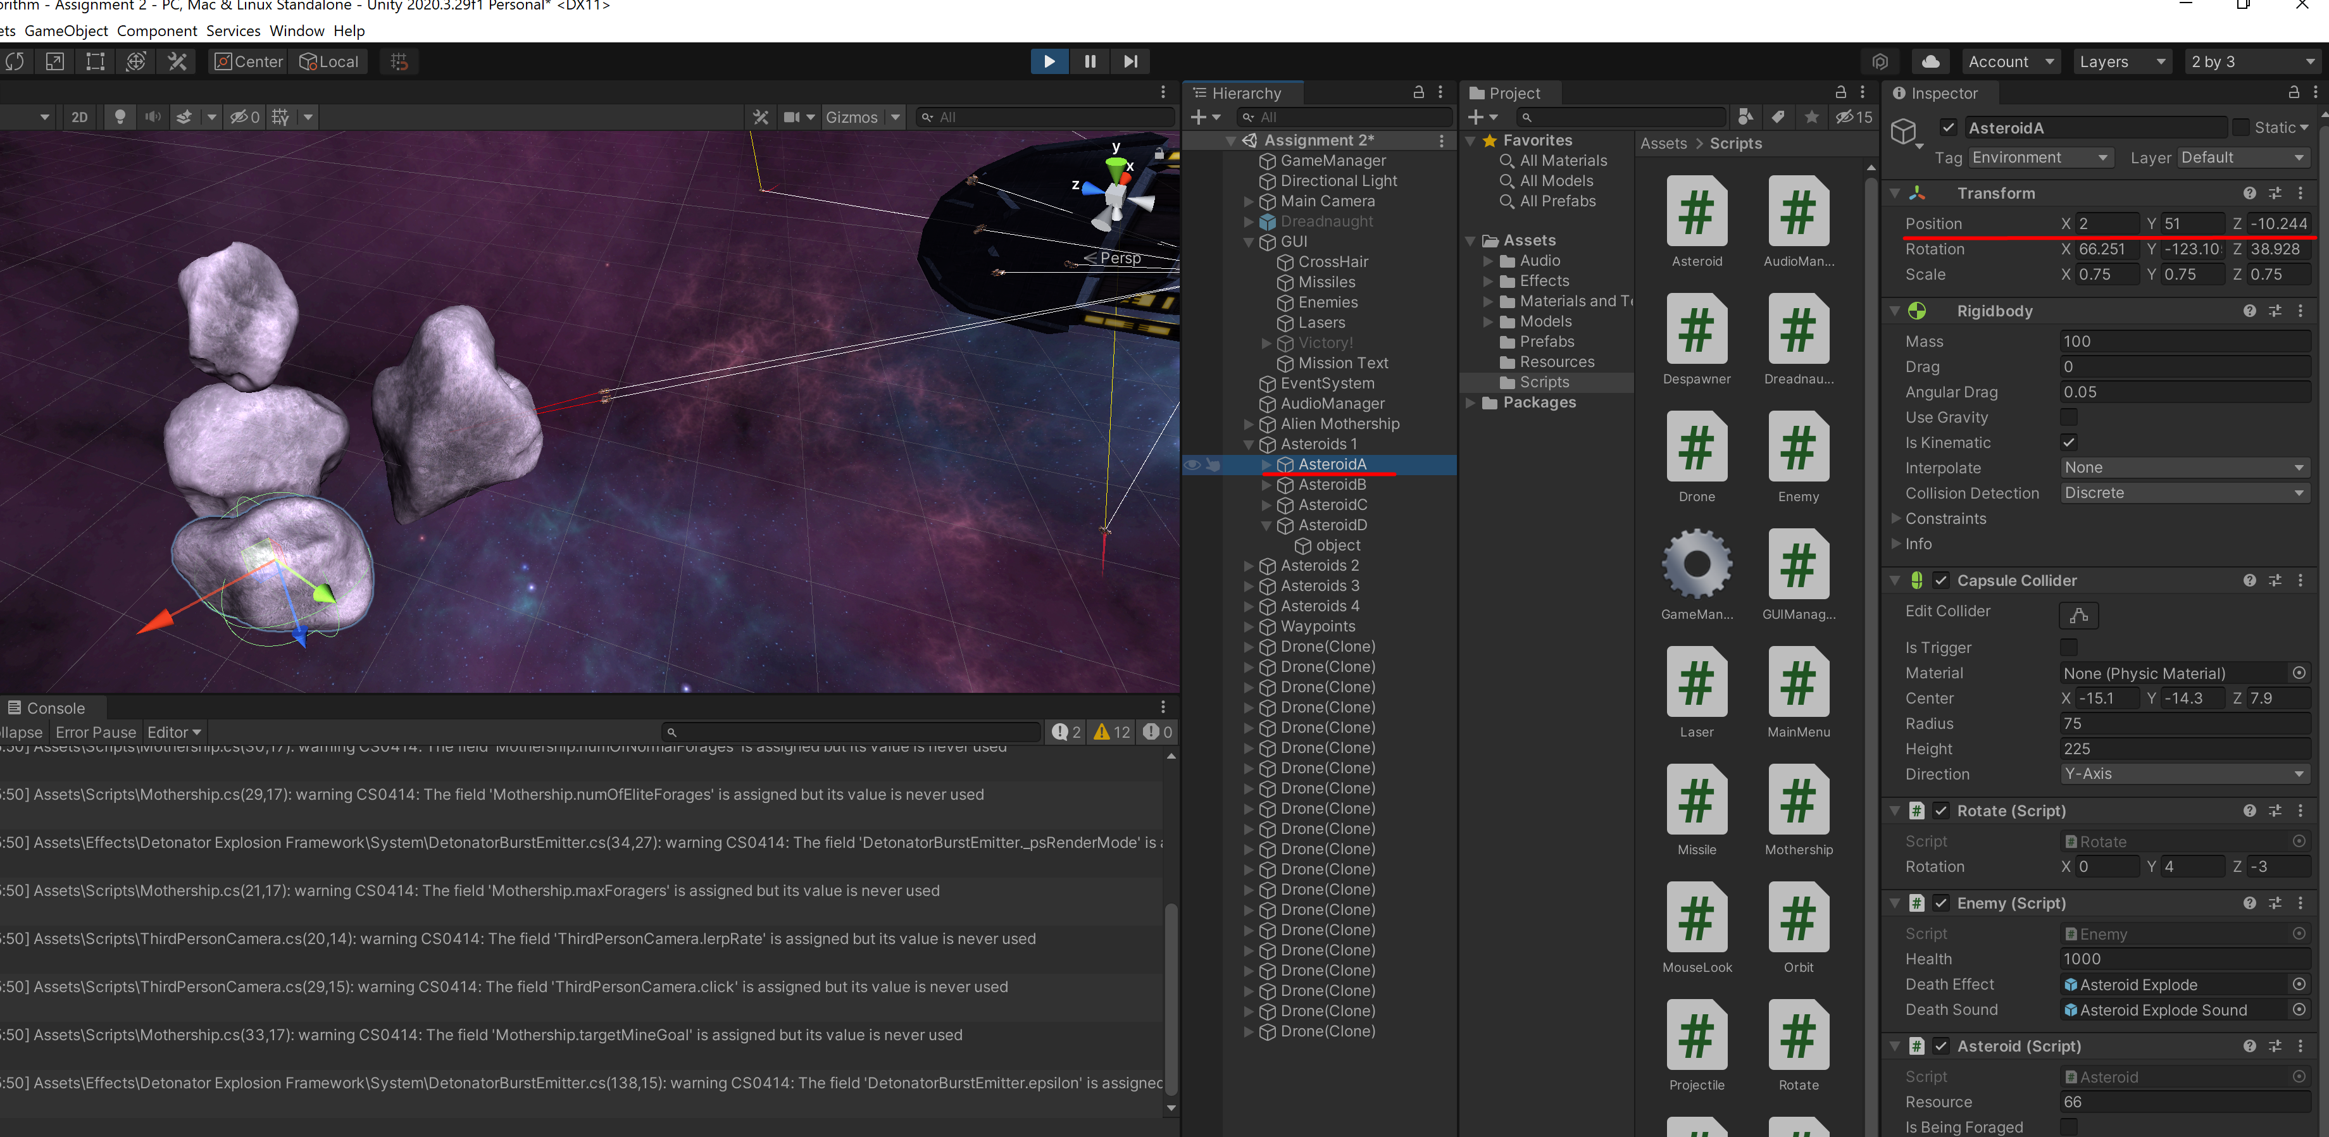

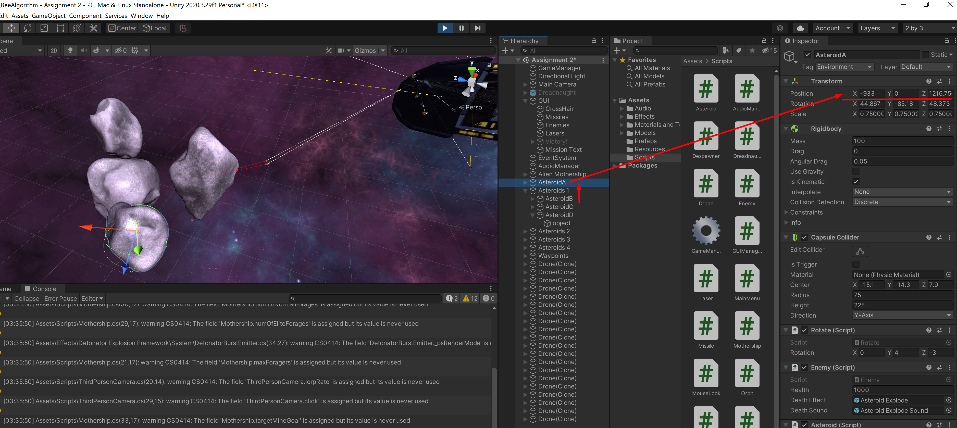

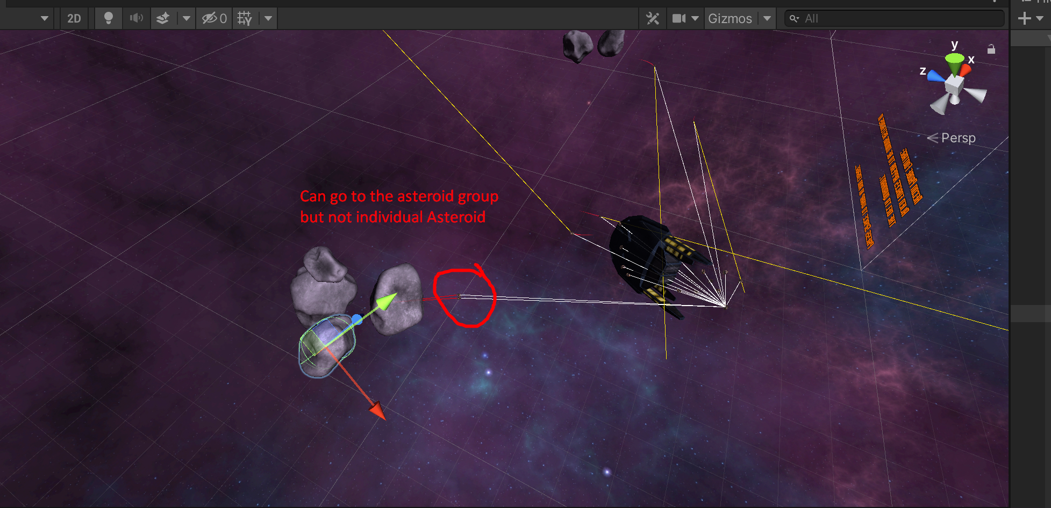

Neighbour hood shrinking

